**LOGIN TO JIRA**

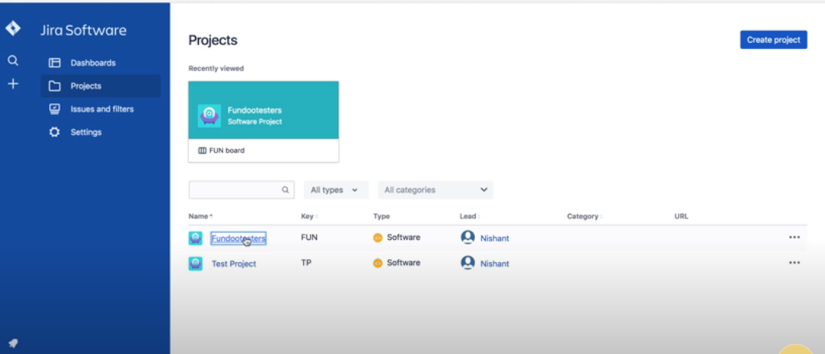

**CLICK ON CREATE ISSUE**

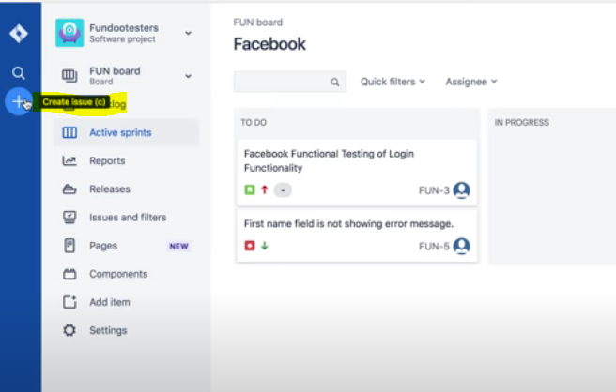

**SELECT PROJECT**

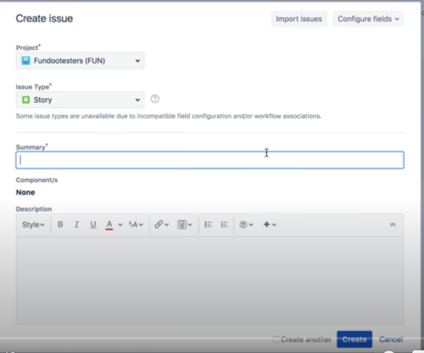

**DESCRIBE THE ISSUE**

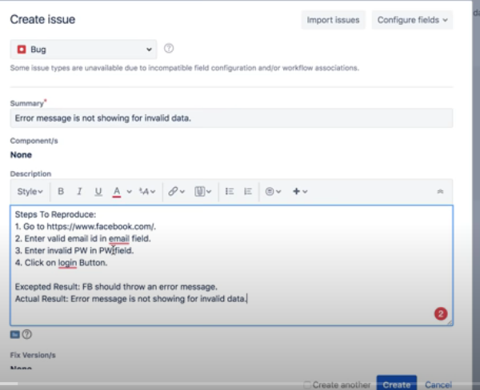

**DESCRIBE ENVIRONMENT & ADD SCREENSHOT OF ISSUE**

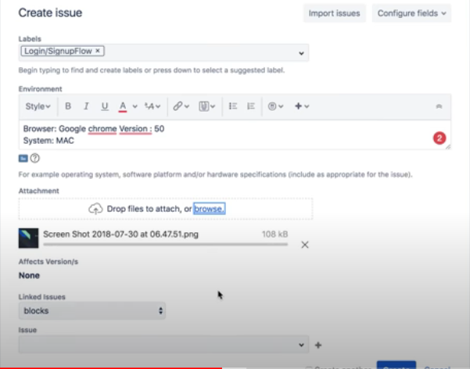

**ASSIGN TO DEVELOPER**

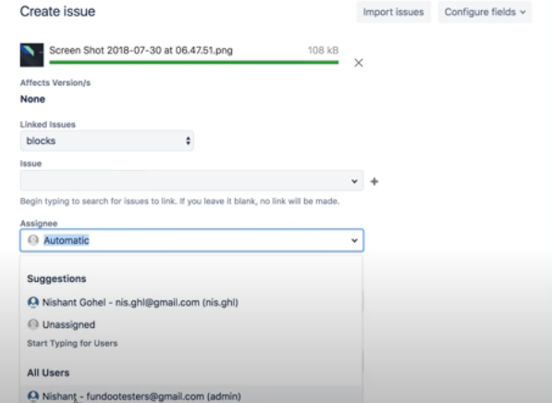

**ISSUE IS CREATED AND SHOWS IN DASHBOARD – NOW WAIT FOR DEVELOPER TO FIX IT**

